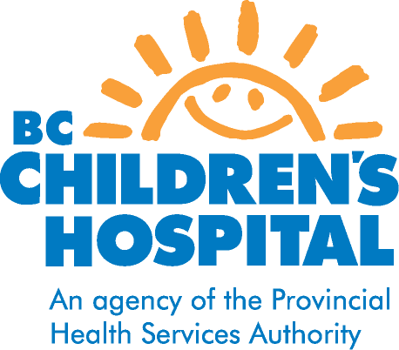

COLCHICINE
DRUG INFORMATION FOR PATIENTS AND FAMILIES

Pediatric Rheumatology

WHY IS COLCHICINE PRESCRIBED?
Colchicine is used to treat periodic fever syndromes such as familial Mediterranean fever (FMF; an inherited condition that causes episodes of fever, pain, and swelling of the stomach lining, lungs and joints). It is also used to treat gout (pain in joints caused by abnormally high levels of uric acid in the blood), although gout is very uncommon in children.

HOW DOES COLCHICINE WORK?
It is not certain how colchicine works to stop fever episodes but it does decrease some products of inflammation like amyloid. Colchicine is not a pain reliever and is not used to treat pain caused by FMF or any other disease.

HOW IS COLCHICINE TAKEN?
Colchicine comes as a tablet to take by mouth with or without food. It is usually taken once or twice a day. Colchicine is usually started at a low dose and then increased slowly to decrease any side effects. The dosage is dependent on your child’s weight.

HOW WILL I KNOW IF COLCHICINE IS WORKING?
For fever syndromes, colchicine is to be given continuously for a period of time as a preventative treatment. The aim of this drug is to reduce inflammation, control the symptoms of the disease and frequency of fever episodes. Colchicine may help during a fever episode and may prevent further episodes. It may take several weeks to fully evaluate the effectiveness of colchicines.

WHAT ARE THE POSSIBLE SIDE EFFECTS?
Most of the common side effects are related to gastrointestinal symptoms. Diarrhea, nausea, vomiting and occasional abdominal cramps can occur. These symptoms generally occur at the beginning of therapy and often settle down. If these symptoms persist they usually respond to a short term reduction in the dose.
Other possible side effects include:
- Muscle pain or weakness
- Numbness in fingers or toes (neuropathy)
- Rash and alopecia (hair loss)
- Unusual bleeding or bruising (decrease number of blood cells)
- Sore throat, fever, chills and other signs of infection

WHAT PRECAUTIONS NEED TO BE TAKEN?
- Taking high amounts of colchicine can be dangerous and toxic. Parents should be very cautious that the drug is not within reach of small children. It is recommended to keep the medication in the container it was dispensed in to avoid small children being able to open the bottle. In case of an overdose, go the nearest hospital emergency room immediately. Taking too much colchicine may cause death.
- Tell your doctor or pharmacist about any other medications you are taking, both prescription and non-prescription.

For any concerns or questions, contact Rheumatology nurse at 875-3678
If urgent call rheumatologist on call @ 604-875-2161 September 2012

