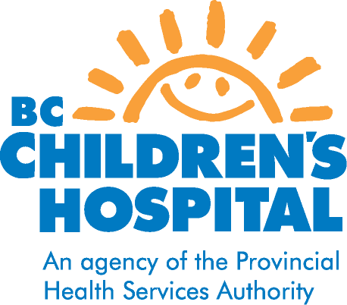
CYCLOPHOSPHAMIDE
DRUG INFORMATION FOR PATIENTS AND FAMILIES

Pediatric Rheumatology
WHY IS CYCLOPHOSPHAMIDE PRESCRIBED?
Cyclophosphamide is used to treat rheumatic diseases such as Lupus, Vasculitis, and other diseases in which there is serious risk of organ damage due to uncontrolled inflammation. It is often used at initial diagnosis if there is serious kidney, lung or brain inflammation. It is also prescribed when the disease has not been well controlled by other immunosuppressive medications such as Prednisone, Imuran, or Cellcept.

HOW IS CYCLOPHOSPHAMIDE TAKEN?
Cyclophosphamide is either taken by mouth or given intravenously. In most cases it is given intravenously. The dosage is dependent on your child’s weight. It is usually given every 3-4 weeks in the Medical Day Unit at Children’s Hospital, or can sometimes be arranged at local hospitals in the community. Most children receive 7 doses followed by another 7 doses every 3 months for 2 years. This may be modified by the rheumatologist depending upon how your child’s disease responds to treatment.

HOW DOES CYCLOPHOSPHAMIDE WORK?
Cyclophosphamide suppresses the immune system, decreasing the activity of cells that cause inflammation. Cyclophosphamide is also a chemotherapy drug used in treatment of certain childhood cancers. However in rheumatic diseases the doses used are much smaller and therefore side effects are much less.

HOW WILL I KNOW IF CYCLOPHOSPHAMIDE IS WORKING?
It may take several months to determine the effectiveness of the drug. Your child may not notice any physical changes while taking cyclophosphamide although improvement will be noted in the blood and urine tests. Benefits include the ability to lower the dose of prednisone without the disease flaring. A blood test will be required 10 days following the infusion to monitor the white blood cells.

WHAT ARE THE POSSIBLE SIDE EFFECTS?
- Nausea, vomiting and loss of appetite. These symptoms are usually mild and short lived. An anti-nausea medication, Ondansetron will be prescribed after each IV infusion to help with this side effect.
- Diarrhea. If diarrhea lasts more than four days or is very severe consult your family doctor or the rheumatologist on call.
- Thinning of hair. This varies a lot from patient to patient. The hair loss always recovers when the drug is stopped. It is very rare for children to lose their hair completely during treatment.
- Irritation of the mucosa of the bladder (cystitis). If your child is getting cyclophosphamide intravenously, your child will receive fluid before and after the medicine to help flush the medicine out of the bladder. To help prevent cystitis when taking this medicine orally it is important to take the medicine in the morning and drink plenty of fluids throughout the day.
- Bone marrow suppression. Cyclophosphamide may suppress the bone marrow’s ability to make normal amounts of red and white blood cells, and platelets. This is monitored by regular blood tests.
- Increased risk of infections. If your child has a persistent fever lasting more than 2 days, or becomes unusually unwell, they should be seen by the family doctor, or/and should contact the rheumatologist on call.
- Skin rash. Rarely does this necessitate stopping the drug.

WHAT ARE THE POSSIBLE LONG TERM COMPLICATIONS?
- There is some evidence suggesting that there may be increased risk of cancer later in life in people who have taken cyclophosphamide. There may also be an increased risk of bladder cancer if your child has had cystitis due to the cyclophosphamide.
- There is a risk of infertility (inability to have children). This risk is dependent on age; the risk is less in children who are younger when they receive cyclophosphamide. The risk in adolescence has been estimated at about 15%-17% (the risk of infertility for healthy couples is between 5%-7%).

WHAT PRECAUTIONS NEED TO BE TAKEN?
- Tell your doctor or pharmacist about any other medications your child is taking, both prescription and non-prescription.
- Cyclophosphamide does not prevent pregnancy; therefore pregnancy must be avoided while taking cyclophosphamide because the drug can damage the fetus.
- Cyclophosphamide may make vaccinations less effective. Discuss with your nurse or doctor before your child receives any vaccines.
- Chicken pox in a child taking cyclophosphamide may be severe. If your child has come into direct contact with someone with someone with chicken pox (and your child has never had the chicken pox or the Varicella vaccine) they should receive Varicella Immune Globulin (VZIG) within 72 hours of contact. This is because if a child on cyclophosphamide gets chicken pox, the illness may be more severe. Notify your family doctor. If your doctor is not available go to your local emergency. If your child gets the chicken pox, contact your doctor. Your child may need an anti-viral medication to lessen the severity of symptoms.
- If any side effects develop or any other problems occur that you think may be related to the drug, contact the rheumatology service.

For any concerns or questions, contact Rheumatology Nurse at 875-3678
If urgent, call rheumatologist on call @ 604-875-2161

Revised September 2012

