
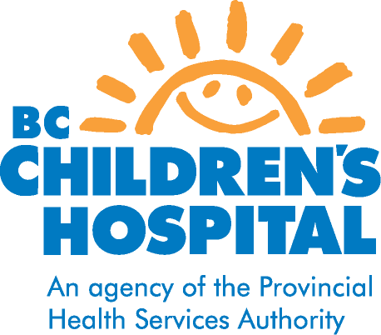
Granulomatosis with Polyangitis or GPA
(Wegener’s granulomatosis)
What is GPA?
GPA is rare chronic disease involving inflammation of the blood vessels (vasculitis). It is an autoimmune disease which means the body’s immune system attacks its own body tissues. There is no known cause for GPA and there is no evidence that it is hereditary. Inflammation of the blood vessels can damage organs in the body by reducing blood flow to these organs. The most common organs affected in GPA are sinuses, lungs, kidneys, eyes, and ears; however other organs can also be involved. Usually the disease affects many organs but sometimes it might only affect one organ such as the kidney, eyes or lungs.

What are the symptoms of GPA?
Many children will present with symptoms similar to a cold, “runny nose” or other cold symptoms that do not respond to usual treatment or become increasingly worse with general symptoms such as fever, fatigue, loss of energy, aches and pains and weight loss. Other respiratory tract symptoms may include nasal congestion, ulcers and crusting in the nose with frequent nose bleeds, persisting sinusitis or middle ear inflammation, shortness of breath and cough that may produce bloody phlegm. Other symptoms may include rashes and ulcers in the skin, joint pains, and blood in urine.

How is GPA diagnosed?
There is not one test that can diagnose GPA, it involves many factors including symptoms, blood tests, physical exam and imaging studies such as x-rays, CT scans and MRI of affected organs. Many children with GPA test positive for antibody proteins in their blood called antineutrophil cytoplasmic antibodies (ANCA). Often to confirm the diagnosis a tissue biopsy (removing a tiny piece of tissue) often from the kidney or lungs is required.

How is GPA treated?
GPA is serious disease that can be life threatening without treatment. Treatment of GPA depends on the severity of the disease and the specific organs that are affected. Newly diagnosed children with severe disease will be treated with prednisone and cyclophosphamide. Cyclophosphamide treatment is usually given over a 4-6 month period and if children have responded well the cyclophosphamide is switched to another medication such as methotrexate or imuran. The few children who have mild disease may be initially treated with methotrexate or imuran. Most children will need to take these treatments for 2 or more years. Prednisone is usually given at high doses at diagnosis but children will often require continuing prednisone at lower doses for more than a year. Another medication option that some children with severe or recurrent disease may be treated with is rituximab (a biologic agent) in combination with prednisone. Specific information about these drugs and side effects will be given by the health care team.

What is the long term outlook for GPA?
There is no cure for GPA but with early intervention and treatment permanent damage to organs can often be avoided or limited and most children do well and go into remission (disease is inactive). However many children will experience a recurrence of “active“ disease – a flare - within the first few years . Therefore it is important that children are followed by the rheumatology team regularly, both while on medications, as well as after these medications have been stopped.

October 2012
Pediatric Rheumatology

