INFLIXIMAB (Remicade)
DRUG INFORMATION FOR PATIENTS AND FAMILIES

Pediatric Rheumatology

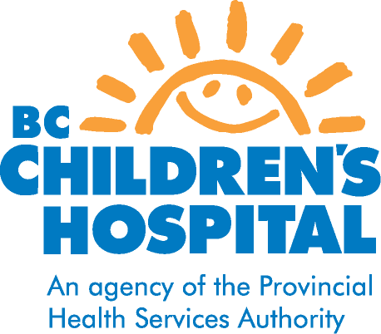
WHY IS REMICADE PRESCRIBED?
Remicade is a medicine used to treat moderate to severe juvenile idiopathic arthritis, uveitis and other rheumatologic diseases which have not responded well to other medicines.

HOW DOES REMICADE WORK?
Remicade is a protein called a TNF blocker. Tumor Necrosis Factor (TNF) is made by your body’s immune system and too much TNF can cause inflammation. Remicade blocks the action of TNF in the body thereby reducing inflammation.

HOW IS REMICADE TAKEN?
Remicade is an intravenous medication that will be administered in the medical day unit at Children’s Hospital. The dose of Remicade varies depending on your child’s weight and how well the disease responds to the medication.
- Once the initial dose is given, subsequent doses are given at 2 weeks and 6 weeks. Your child will then receive a dose every 6-8 weeks depending on disease response and severity.
- You can expect to be in the medical day unit for 4 hours for each infusion
- Your child may continue on other medications prescribed by our rheumatologist in combination with Remicade.

HOW WILL I KNOW REMICADE IS WORKING?
It may take several months to determine the effectiveness of this drug. Effectiveness may be noted by:
- improvement in general symptoms (less swelling, less pain and stiffness of joints)
- improvement in blood tests
- lower dose of prednisone required
- eye drops used less frequently

WHAT ARE THE POSSIBLE SIDE EFFECTS?
- Increased risk of serious infections such as respiratory infections (sore throat, sinus infections), tuberculosis (TB), bacterial infections, or skin infections such as abscesses.
- Coughing, headaches, stomach pains
- Some children have developed auto-antibodies suggestive of a lupus-like syndrome although these children remained asymptomatic.
- Allergic reactions can occur during or shortly after an infusion. Possible symptoms may include:
Dizziness Hives
Difficulty breathing Chest pain
Nausea Weakness
Delayed allergic reactions can occur 3-12 days after treatment and may include muscle or joint pain with fever or rash. Call your doctor should this occur.
- There have been reports of a small increased risk of developing certain cancers in children taking Remicade; this risk was reported in children taking the medication for longer than 2 years.

WHAT PRECAUTIONS NEED TO BE TAKEN?
- Blood tests must be done every two months to monitor for possible side effects of Remicade.
- Tell your doctor or pharmacist about any other medications you are taking, both prescription and non-prescription.
- Your child should not have immunization injections involving any live vaccines such as MMR or varicella. Flu vaccine and pneumovax are safe.
- Pregnancy must be avoided while taking this drug as it may damage the fetus.
- Tell your doctor or nurse if your child has ever had tuberculosis (TB), a positive skin test for TB, or has been in close contact with someone who has TB.
- Tuberculin testing prior to starting this medicine is recommended if it has not been done within the last year.
- If your child has a serious infection this medication will not be given. Contact your doctor or nurse if your child is ill before coming in for treatment.
- If you develop any side effects or any other problems, and you are not sure if they are related to the drug, contact your doctor or clinic nurse.

For any concerns or questions, contact Rheumatology nurse
If urgent call rheumatologist on call@ 604-875-2161

December 2012

