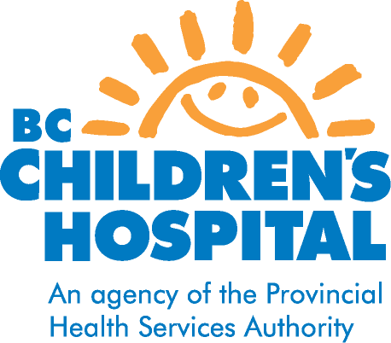
METHOTREXATE
DRUG INFORMATION FOR PATIENTS AND FAMILIES

WHY IS METHOTREXATE PRESCRIBED?
Methotrexate is a disease-modifying drug used to treat Juvenile Idiopathic Arthritis, Juvenile Dermatomyositis and other rheumatic disease. Methotrexate is used in low doses when non-steroidal anti-inflammatory drugs (NSAIDS) such as Naproxen and Ibuprofen do not adequately control the disease. Many children are on Methotrexate with an NSAID. Methotrexate is also used to treat cancers however it is used in much higher doses.

HOW DOES METHOTREXATE WORK?
Methotrexate helps to decrease the production of the cells of the immune system that activate inflammation and causes the body to produce an anti-inflammatory molecule called adenosine.

HOW IS METHOTREXATE TAKEN?
Methotrexate can be taken orally or by injection. The pills come as 2.5mg or 10mg tablets. The injectable form comes as 25mg/ml and should be stored in the fridge away from light. It is given once a week on the same day. It may be easiest to take on a Friday or Saturday evening (i.e. not a school day), in order to allow time for your child to rest in case of ay side effects, such as fatigue or nausea. A vitamin Folic acid is taken to help minimize side effects. It usually started at 1mg daily but can be increased if side effects occur.

HOW WILL I KNOW IF METHOTREXATE IS WORKING?
Methotexate usually takes a number of weeks, even months to determine if it is working.
Effectiveness is determined by:
- By your child’s increasing ability to do physical activities.
- Your child may be less tired
- Your child may begin to grow again after a period of slow growth.
- Improvements in your child’s blood test results.

WHAT ARE THE POSSIBLE SIDE EFFECTS?
- Nausea or loss of appetite the day after taking the medicine. In rare circumstances, the nausea may be so severe the child vomits.
- Mouth ulcers/sores
- Bone marrow suppression: methotrexate can suppress the body's ability to make normal amounts of red and white blood cells in the bone marrow. This is monitored by regular blood tests.
- Liver toxicity: This drug may affect the cells of the liver. Liver function tests are blood tests that advise the doctors the health of the liver. Normal childhood infections such as colds and flu's can elevate these tests but if your child's tests are abnormally elevated, the medication may be stopped temporarily, or the dose reduced.
- Lung complications: This is an extremely rare possibility. If your child has increasing shortness of breath that is not due to a cold or allergies see your family doctor.

INSTRUCTIONS FOR MONITORING METHOTREXATE
- A blood test will be required after the first four doses and then every 2 months. It is important to have the blood tests done to safely monitor for possible side effects of the drug.
- Choose a medical laboratory close to where you live.
- If your child is ill with a flu or cold when it is time for your child to have a blood test, wait at least a week and then have it done.

WHAT PRECAUTIONS NEED TO BE TAKEN?
- Children who develop the chicken pox while on methotrexate can become quite ill; therefore, it is necessary to follow these precautions if your child has NOT had the Varicella vaccine:
- If you child has been in direct contact with a child with the chicken pox, your child should receive Varicella Immune Globulin (VZIG) within 72 hours of the contact. Your family doctor should be contacted as soon as possible or if he or she is unavailable, go to the nearest emergency department.
- If your child develops the chicken pox, please call your family doctor. Your child may need an antiviral medication.
- Methotrexate can damage the fetus, so pregnancy must be avoided while on this medication. If your child is sexually active, it is recommended that they use reliable forms of birth control. Pregnant or breastfeeding parents should not handle the medication. Gloves should be worn while withdrawing injectable methotrexate or handling the tablets.
- Avoid alcohol. It can greatly increase the risk of liver toxicity when combined with methotrexate.
- Remember not to take medications containing Sulfa or Aspirin.
- Do not take any additional medications without letting your doctor know. Medications and natural health products could interact with Methotrexate and cause increased side effects.
- If your child develops any side effects, contact the clinic nurse or the rheumatologist on call. There are many ways to combat the side effect of nausea from Methotrexate. Please call the clinic nurse if your child is having this problem.

For any concerns or questions, contact Rheumatology nurse
If urgent call rheumatologist on call@ 604-875-2161

Revised December 2012

