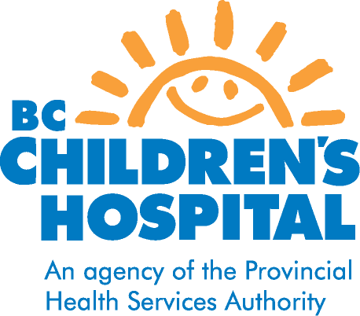
Food For Thought

Prednisone and your Diet

Many of you may have or know someone who has lupus, juvenile dermatomyositis or other rheumatology conditions. These can cause inflammation in skin, muscles, joints or organs. One of the most common medications used to treat these kinds of conditions is called prednisone.

- Prednisone works by reducing the inflammation

Prednisone can cause some side effects, depending on what dose you are on. These side effects include:
- a bigger appetite
- weight gain
- high blood pressure
- weak bones
- high blood sugars

These side effects might sound scary, but it is really important to keep taking your prednisone. The good news is that there are things you can do to help make the side effects better. These are good tips for most people, so share them with your family. It is easier to make diet changes if everyone around you is making them too. Let’s look at them one by one.

A Bigger Appetite
When you first start on prednisone, you may notice that you are hungrier. As your prednisone dose gets reduced, this should go away. In the beginning, though, eating three meals per day may not be enough to keep you full.
- Try having a small snack 2 – 2 ½ hours after your meal to tide you over until your next meal

Your day will look something like this (times may be different):
7:30am – breakfast
9:30am – snack
12:30pm – lunch
3:30pm – snack
6:00pm – dinner
8:30pm – snack

Now, let’s talk about what to eat at these meals and snacks!

Weight Gain
As you get hungrier and start eating more, you could start to gain weight. Here are some tips to help keep you from gaining too much weight.
- Try to eat fruits and vegetables 5 times every day (They don’t have a lot of calories and the fibre will help to keep you full).
- Eat whole wheat bread instead of white bread (The fibre will help to fill you up).
- Switch to lower fat milk (skim, 1% or 2% milk) instead of whole milk. Also try low fat cheese and yogurt.
- Avoid high fat meats like bacon, sausages, bologna, hot dog, pepperoni and salami. Instead, try more fish, lean beef and chicken without the skin.
- Watch out for fried foods like French fries, burgers and nuggets.
- Avoid breaded foods like fish sticks and chicken strips.
- Try not to add a lot of butter, margarine, salad dressing or gravy to your food.
- Cut back on desserts like cakes, pies, chocolate and creamy ice cream. Instead, try ginger snap cookies, angel food cake, low fat ice cream, frozen yogurt, sherbet or fruit for dessert.
- Drink 4-6 cups of water everyday. Water has no calories, it will keep you full and you’ll have more energy because you won’t get dehydrated.
- You may not always have a lot of energy, but try to keep active. Walk, dance or play sports that you enjoy.

Here is what your plate should look like:

Grains
rice, potatoes, pasta,
noodles, bread
Vegetables

Protein
meat, chicken, turkey,
fish, tofu, lentils,
baked beans

** Don’t forget to add some yogurt or a cup of milk or water!!

- Do not use diet pills or other diet products to lose weight! These usually make you lose water weight (not fat), and this is not the kind of permanent weight loss that people want. These diet products can also cause very serious side effects.

High Blood Pressure
Blood pressure is complicated, but basically it measures how hard our heart has to work. Salt and water are like best friends. Wherever salt goes, water likes to follow. When we have a lot of salt in our diet, then it draws more water into our body. This means that our hearts have more fluid to pump around our bodies and this means more work for our hearts. So our blood pressure goes up.
- Try not to add salt to your food. You can try pepper, lemon juice or herbs and spices for flavour.
- Avoid “junk food” like potato chips and fast food. These are very salty.
- Avoid salted snacks like peanuts, saltine crackers and popcorn. Try the unsalted kinds instead.
- Limit convenience foods like microwave meals and frozen dinners. These usually have a lot of salt in them.

Weak Bones
Think of a piggy bank or a bank account. If you save your allowance or paycheque, then you’ll have lots of money in case you need to buy something. But if you keep spending more money than you save, then eventually you will run out.

Your bones are like a bank account or piggy bank, and calcium is like money. Prednisone is like a little hand that grabs calcium from your bones! If you have a diet with enough calcium, then your body can save it in your bones. If prednisone tries to take some calcium out, it’s okay as long as you keep putting more calcium back into your bones – otherwise you start to run out. If you don’t have enough calcium, then your bones become weak and can break or fracture more easily.

So where do you find calcium?
- dairy products like milk, yogurt and cheese.
- Some brands of soy milk and orange juice have calcium added to them (look for “calcium-fortified” on the package).

How much calcium do you need?
- You need about 4 cups of milk, yogurt and calcium-fortified soy milk

- It is not a good idea to get all your calcium from fortified orange juice. Juice has a lot of sugar in it.
- Avoid dark colas (Coke, Pepsi) and rootbeer. These guys are very good at grabbing calcium from your bones (whether someone is on prednisone or not)!

High Blood Sugars
Prednisone can make your blood sugars go high. This can make you feel thirsty, tired, dizzy or cranky. If you eat or drink a lot of sugary foods, this can make your blood sugars go even higher.
- Limit juice. Have fresh fruit instead.
- Avoid colas and rootbeer. They have a lot of sugar.
- Limit candies and sweets.

- Water and milk are better choices for fluids.

Parveen Khattra, Dietitian
Revised November 2012

